[Topic: Contextual Statement: Virtual, Augmented reality Medical education and practices in medical surgery]

[Amandeep Kaur]

[Contextual Statement]

9th October 2021

Table of Contents
Project Plan 2
Landscape 3
Contemporaneity 3
Augmented Reality in Medical Education 3
Utility of Virtual Reality and Augmented Reality in Spine Surgery 4
PubMed Search Engine 4
Interaction 5
Methods: 5
Augmented Reality Applications in Medical Training 7
Development 8
Augmented Reality in Emergency Medicine 8
EXPLORATION 9
Augmented & Virtual Reality Protocol To Develop Evidence-Informed Program Theory 9
Creativity and Innovation 9
12 Augmented Reality application for the Class room 10
Originality 11
Augmented Reality and pedestrian navigation through its implementation in m-learning and e-learning 11
Augmented Reality in Surgery 11
Neurosurgery 12
Process 12
Indicators of Success 12
VR &AR on Gamification, Telerehabilition Psychological Impact on Patient 13
Augmented & Virtual Reality Based Head Mounted Devices for Medical Education 13
References 15

Virtual, Augmented reality Medical education and practices in medical surgery: Contextual Statement:

Project Plan
This project is going to work on virtual reality and augmented reality and the investigation of these fields deployed on medical surgery. Various medical surgeons used simulation based tool to practices the operation process before real surgery. This project is highlight various medical fields medical surgery augmented reality based system. Mainly focused on United States of America and United Kingdom. The aim of the project to highlight the main focus on medical surgery because various medical surgery process failure due to negligence of doctor and less practices over the time. Methodology of the project basically collect the previous data and analyze them in proper way on various medical surgery processes such as orthopedic operation, breast biopsy, carotid enderaterectomy, cataract surgery and so on. The healthcare department required more investigation about to develop sustainable medical surgery which is based on virtual reality and augmented reality, it convert the real digital image into a 3D image which helpful for the investigation of the surgery of the patient. Various medical fields at Washington United States and California works on augmented reality and virtual reality based system that treat, operate and investigate the patient disease and problem. Virtual reality provides the simulated interface to interact with 3D technology imaging, it expand and visualize the digital imaging process into a computer vision based image processing system which is based on medical imagery 3D CT scan images. It was able to treat the patient disease about to evaluate the timeframe of the surgery and illness of the disease and life of the disease. The diagnosing procedure of the patient during the critical situation of the circumstances, this project also highlight the processes involved implementing in the technology in the medical field. This project investigate the 14 different medical fields’ application about to using the augmented reality based system to carefully implement the technology by latest trends and business objective. VR efficiently used for better surgical method, it creates the virtual model of the patient structure, it helps the physician to move forwards to investigate the 3D images of the patient, it currently deploy in cardiology and neurology fields of medical science. VR reality technology vastly used in United States due to increasing demands of the practitioners of medical field doctors. (Javaid & Haleem, 2019).

Landscape
The landscape of the project to deploy the system which is based on augmented and virtual reality based, and works on various medial surgery such as neurology and cardiology surgery. The technology helps out the doctors and nurses to treat the patient by using the various 3D imaging technology, the 3D imaging system based on virtual reality and explore the patient disease in more details and expand the outcomes and drawbacks of the patient disease with different time frame. The simulation procedure helpful for the medical scientist to explore medical surgery in virtual environment before implementation of the real surgery. It also removes the errors and problems during the surgery processes.

Contemporaneity
The system permits the surgeon to completely organize the surgery itself, it offered great flexibility to the surgeon to receive all relevant information of the body part which supposed to operate in some hours, but the accuracy of the system still challenging question of research to investigate more knowledge about to expand the system. (Katio, et al., 2015) There are three parts of augmented reality for implementing the real virtual reality based methods, it handle the complex understanding of surgery which is intermitted part to develop the operative system without any error and problem. AR is the technology that adds the virtual content to the physical real world.

Augmented Reality in Medical Education
(Kamphius, et al., 2014) Augmented reality widely used in medical education due to the increasing demands of medical practices of medical surgery, fresh graduate students of medical science needs surgery practices, virtual reality 3D image framework devices helps a lot to deploy and implements the technology of novel to operate and test validate and verify the operation procedure before actual implementation of surgery. Educational technology and augmented reality technology potentially to creates a work together to meet the challenges and issues of medical science, augmented reality is the technology which adds the virtual content to the physical real world therefore implementing the technology into a real platform. Empirical research deployed to gather the data of creative information regarding the augmented reality based devices. To handle and manage the complex causality in health department the vast usages of virtual reality based devices increasing in United States of America with lot of practices and deployment that leads towards the move the medical science in artificial intelligence world.

Utility of Virtual Reality and Augmented Reality in Spine Surgery
(Yoo, et al., 2019) Recently the augmented and virtual reality put a lots of efforts in medical science fields to develop the real time surgery implementation without any problem and errors. So there is need lot of practices to operate the surgery without any loss of patient health and life there is need of computer generated automated guided based augmented reality devices that puts on heads and eyes of the surgeon and guide the surgeon to be able to operate the surgery in timely manner without any problem, the device is also guide and communicate between the surgeon to surgeon. It also helps a lot in between the communication between the surgeon to deploy and bind the surgery. Virtual reality basically used in medical education as a teaching and learning perspective beside this augmented reality technology is proper way to deploy and implement the real scenario without error prone. While augmented reality has been utilized in surgical setting.

PubMed Search Engine
(medicine, 2021) pub medical science search with more than 33 million citation of biomedical literature, medicine and life science journal with online books, pub medical search engine support to search the medicine related product. It support all medical queries related to the therapy, clinical predictions, diagnose, etiology, prognosis. It supports all medical science queries, more than 3 billion database of medical science.

Figure 1: Pub Med Search engine
The pub medical data science database also exist to analyzed and predict the medical science fields related to the all practices of surgery, neurology, ENT, medical unit and all medical science related data available to query and make suggestions and predict the relevant information into one framework
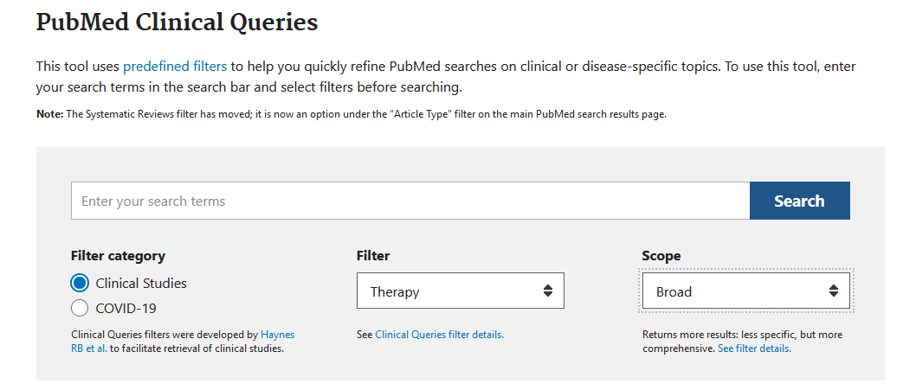
Figure 2: PubMed Clinical Queries.

Interaction

The method of augmented and virtual reality system as follows:

Methods:
All of the creative studies printed on reputed journals, data has been collected from various medical science fields’ journals related to augmented reality and virtual reality technology usages in medical education to train the medicals unit and ready to deploy the personnel to make surgery and operate the surgery with various function and tools. Spine surgery, orthopedic surgery, ENT surgery, brain surgery. The keywords to finding the creative medical surgery data as follows: “Medical Surgery”, “Augmented Reality in Medical Education” , “Medical Virtual Reality”, “Medical surgery in VR , AR” ,”Spine Surgery” etc. MEDLINE, SCOPUS, JOURNAL of medical science discovery.

USE Case Model 1: (Augmented Reality in Medical Education)
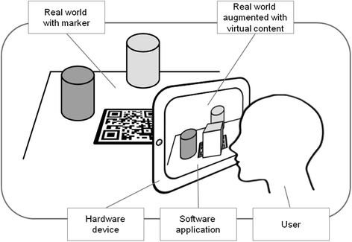
Augmented reality based technology provides training and effective education to the medical education department which helps a lot of medical science students to takes parts in the medical surgery during deployment in the medical unit. The work of CT scan image also based on 3D model image of virtual reality model, which used to identify the damage in the body of the patient, also used to recognize the disease.

Use Case Model 2: Magic Mirror miracle augmented reality of CT scan image
In medical unit
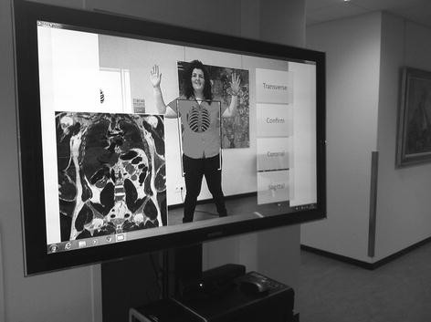

Augmented Reality Applications in Medical Training

(Barsom, et al., 2016) Computer created applications used widely in the medical science fields to provide the support and effective training to the medical professional, because augmented reality applications works on upper layer of virtual reality based work to teach and education the medical person in the virtual environment, this virtual environment known as the real world environment to be considered as best case model to effectively educate the personnel. AR blend the digital elements with physical learning environment which support the learning environment to train and support the medical.
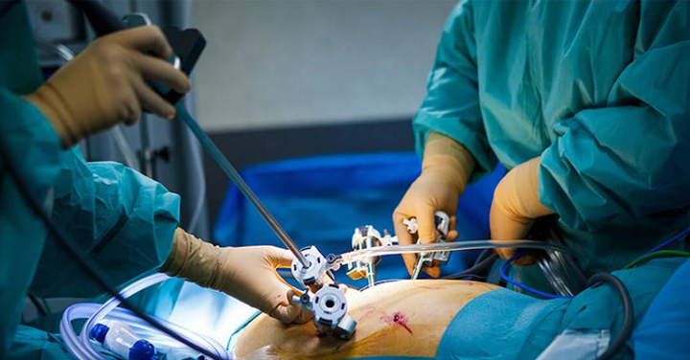
Figure 3: hands on training based on VR and AR laparoscopic surgical training
Collected 27 studies which is based on different surgical data such as the first category leads to laparoscopic surgical training and second data which found to mixed reality training based on neurosurgical procedure and the third category of studies found on echocardiography , image processing computer vision is deeply involved in augmented reality analysis its branch of artificial intelligence methods to process the image into different segments and evaluate each segment into different bits and process the image in grayscale and 3D shape as well as conversion the digital image into a binary image to calculate the region of the image. The deployment of augmented reality and virtual reality based segmentation of patient treatment which is very useful method to identify the body element which needs to be evaluated and treated and its leads towards the technique of virtual reality segment that helps the medical profession in more sophisticated manner. AR, VR also support to identify the originality of the medicine, due to lack of knowledge about the identification of real medicine so it’s also helpful to identify the medicine real chemical content.

Development

The development procedure to evaluate and identify the patient disease discovery with the help of artificial intelligence based technology which ideally helps the medical professional to operate the surgery in more organized way.

Augmented Reality in Emergency Medicine

(william, et al., 2019) Augmented reality widely used in medical science to help out the medical professionals which leads to the educational instructor, the capability of medical training which is also applicable to the training and development of discovery of the emergency medicine treatment. AR also helps out to identify the emergency medicine which is sufficient either or not to treat the patient on priority bases or not. The method which is used to identify the emergency medicine SCOPUS database used as well as medical science articles also used to evaluate the studies of medical science, augmented reality also used in remote location of distance location of the patient, it enable the medical unit to send the medicine through robotics, because augmented and virtual reality generate map location, it also used the Google API’s to capture the map service on real time case and capture the location of the patient which required the medicine at place of residence. Internet of things based devices also used augmented and virtual reality framework to capture the object and identify the problem.
(MSJ, 2018) Augmented reality building the model about 3 decade to building the roles models systems experience to building a 3D model of immersive therapies to treat the patient posttatraumic stress disorder (PTSD), by training the clinical profession to treat the mental health of the patient which discovers from the brain element, various colleagues of medical unit that tackle the situation of brain discovery to re-create traumatic situation with emotional response to handle the therapy, they get the idea from the younger generation which is effectively used the virtual reality gaming system. Younger generation widely used VR based game station to learn various education elements from the junk of data which evaluate the object and take decision on critical situation to handle the disaster system in gaming situation, the idea is very helpful in the treatment of brain mental disorder situation by the medical professionals.

EXPLORATION

The exploration method of augmented and virtual reality segments which leads to discover the medical science training that effectively treat and establish the medical surgery effectively. Proprio vision technology widely used in Washington medical university to train and educate the students to get knowledge of medical surgery with effective methodology.

Augmented & Virtual Reality Protocol To Develop Evidence-Informed Program Theory

(Gasteiger, et al., 2019) Augmented and virtual reality increasing demands in the medical fields of science due to the development of real data science discovery of medical unit system, AR assist like a nursing protocol in health department and taking care of surgical nursing and provides the real time assistance to treat the patient, various studies found to evaluate the AR and VR with evidence of mix training method with effectiveness methods to deploy the surgical system put into a framework of one unit treatment, the evidence information of program theory deployed effectively on sensor of AR system that deal the 3D image generations, that extends the image generation discovery. Collected data from SCOPUS, CINAHL, EMBASE education resource information center and medical unit of web of science, it also evaluated through to collect the grey literature with snowballing information extraction system literature. The theory of mix method which analyzed through the mix method of appraisal tool, the information evaluated and calculated through the initial program theory with information evaluation matrices.

Creativity and Innovation

(Klopfer & Squire, 2008) The arrival of augmented and virtual reality based system which leads to the success of novel creativity impact on artificial intelligence and computer vision branch. Computer vision is branch of image science of artificial intelligence which leads to the detection of object, recognized the object, evaluate the mathematical function of digital & 3D image, the real image converted into a binary image, which provides the real interface of the image that easy way to calculate the mathematical property of the image. Computer vision branch is installed on augmented reality and virtual reality system. Various application in young generation about the gaming platform of education learning which provide the interface of brain polish system to engage the student to take interest to playing the games as well evaluate their studies material in the virtual environment and take decision as well. The purpose of augmented reality in educational gaming that support the brain skills of the students of K-12 student to take decision on critical situation, it enable the self-confidence of the student. The rapid proto type of augmented method internally programmed with AI based programming based method it may be python based programming and C programming as well. The educational software to support the student’s discovery method that evaluate the system of virtual.
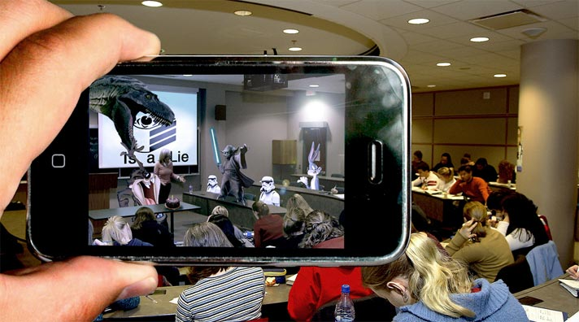
Figure 4: 12 augmented reality application in the class room

12 Augmented Reality application for the Class room

(though, 2021) Augmented reality application considering as a one of the growing fields of artificial intelligence which upwards the platform of education into a next level education training platform. the most common AR which perceived through the mobile applications, various Samsung mobile cellular system enhance and built in AR and VR functionality, that is new creativity and innovation of smart phone user. The AR based video training methods widely used in educational institute which effectively train and education the junior students in the class room. There are as follows augmented reality application which widely used during the class session in class room.
- JigSpace, this application deal with the 3D diagrams and 3D objects with 3D models with historical battles pattern
- Complete Anatomy 2021, this application deal with medical students which helps to identify the object of muscles, using this app student able to evaluate the structure of bone in 3D model construction with heart, nerves and muscles.
- Adobe AERO, this application indications to the learning to play the, which allows the student to play spawns to get involved in the object.
- Animal Safari AR, animal safari 3D object recognition is the way to learn the students about the discovery of animal science, which handles to recognized the animals noises, threats, and feed it probably recognized the each object of animal into a deeper look.
- SOIAR, the AR solar system allows the students to have fun with astronomy, some of the features of planets studies such as earth, mars and so on.

Originality

Augmented Reality and pedestrian navigation through its implementation in m-learning and e-learning

(Nagata, et al., 2017) The development pedestrian by using the mobile pattern navigation in the augmented reality application in the context of learning the students though the mobile device, which navigate the pedestrian information on real time situation it also enable the student to identify the pattern of footpath with image data set. The application mobile navigation map is looking this matter to evaluate the teaching tools which facilitate the students of medical science.

Augmented Reality in Surgery

(Jeffrey H. Shuhaiber, 2004) The potential goal of augmented reality to train the surgeon before surgery and patient treatment effectively. Data collected from National library of medicine database, augmented reality is the way to effectively treat the patient surgery with the methodology of training and simulation modelling of augmented reality the evidence of medical science with stereotactic registration and ergonomics with strong evidence of effective teaching tools in the operation room, AR generates the 3D paradigms and execute the object with pattern based registration the specific object, the difference between AR and VR that based on 3D model and video and image segmentation system.

Neurosurgery

The procedure of neurosurgery required the true features of augmented reality and virtual reality based framework, neurosurgery is always respect the smallest object of brain tissue with tumor that ideally identify and recognized through the AR based device. The method to structure the 3D framework of brain, the surgeon able to see the actual anatomy of brain structure by using these methods, and understanding of stereotactic surgery and stereoscopic surgery effectively works on the framework of AR, to identify the solution of brain tumor the best example to seen the stereotactic frame of the patient skull. The AR system navigate the whole framework to enabling 3D map of image with volume graph of brain that assist the surgeon to operate and treat the brain object that specifically caused with tumor.

Process

(Image, et al., 2019) By using the augmented reality in medicine processes widely implemented almost in all countries specifically in United States of America, California, and Washington to integrate the digital information in 3D image virtual based information that provides the interface of medical science to produce the effective medicine with the structure of proper way of augmented reality recognition system, augmented reality helps in medical surgery to assist the surgeon in the way of treatment of medical surgery, the method of augmented reality based medicine discovery which effectively treat the patient health and aid the patient required medicine on timely manner. Augmented reality devices researched through the clinical trial of the medical unit, clinical studies provides the mechanism to identify the pattern and the way of augmented reality method to operate the patient with surgery method.

Indicators of Success

(Eagleson, 2014) The immersive 3D object mapping effectively possible through the virtual reality and augmented reality based system, the educational game in medical science to assist the surgeon how to operate and treat the surgery with various effective tools and technique. There are various surgical training simulation available all equipment are based on VR and AR system. The context of medical education by using the surgical training system into the virtual simulation model with serious games of medical unit.

VR &AR on Gamification, Telerehabilition Psychological Impact on Patient
(Berton, et al., 2020) During the covid19 pandemic situation the AI assisted technology contain Virtual reality and augmented reality feature to identify the psychological facts of the patient by recognizing the 3D image of the patient of corona virus infected patient. The characteristics of gamification and telerehabilition of the patient psychology easily identify with virtual reality framework.

Augmented & Virtual Reality Based Head Mounted Devices for Medical Education

(Image, et al., 2021) Augmented & virtual reality mix technology devices which mounted on heads in the technical way to treat the patient effective technical method of construction the 3D image map of virtual reality based system to identify the surgery area as well as surgery object segment easily identifiable. The setting of head mounted devices which is leading to treat the patient discovery with various angle. The medical education in United States effectively deploy the various AR based system in the medical universities to train the undergraduate and graduate students. Results has been obtain with various medical anatomy of brain surgery because in brain surgery the smallest element of the object easily identify through the AR and VR model to identify the each element of neurosurgery. The methods of identification modelling of system to construct the model of virtual map which easily identifiable in the environment. The handheld devices to identify the surgery portion that extract with different 3D modelling system.
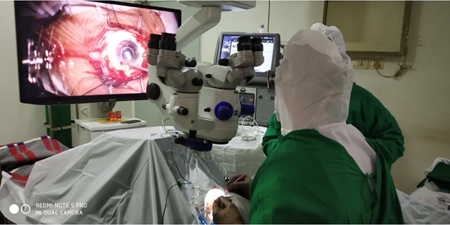
Figure 5: 3D object of patient recognizing OPD
Training and validation method of VR and AR based devices with different clinical trial to investigate the disease of the patient on particular areas of the system. These devices assist the surgeon to treat the surgery effectively in more organized manner. The clinical tail data set has been collected with reliable sources.

References
Barsom, E., Graafland, M. & Schijven, M., 2016. Systematic review on the effectiveness of augmented reality applications in medical training. Surgical Endoscopy, Volume 30, pp. 4174-4183.
Berton, A., Longo, U. G. & Candela, V., 2020. Virtual Reality, Augmented Reality, Gamification, and Telerehabilitation: Psychological Impact on Orthopedic Patients’ Rehabilitation. Journal of clinical medicine, 9(8), p. 2567.
Eagleson, S. d. R. K. H. S. D., 2014. Healthcare Training Enhancement Through Virtual Reality and Serious Games. Virtual, Augmented Reality and Serious Games for Healthcare , Volume 1, pp. 9-27.
Gasteiger, N., Veer, S. N. v. d. & Wilson, P., 2019. Upskilling health and care workers with augmeneted and virtual reality protocol for a realist review to develop an evidence-informed program theory. Medical Education and Training Protocol, 11(7), pp. 1-8.
Image, M. E. 1. A. O., Image, J. S. V. 1. A. O. & Christoph M Friedrich 1, 2. A. O. I., 2019. Augmented Reality in Medicine: Systematic and Bibliographic Review. JMIR Publications, 7(4), p. 1.
Image, S. B. 1. A. O. et al., 2021. Augmented, Mixed, and Virtual Reality-Based Head-Mounted Devices for Medical Education: Systematic Review. JMIR publications, 9(3), p. 1.
Javaid, M. & Haleem, A., 2019. Virtual Reality applications towards medical field. Clinical Epidemiology and Global Health, pp. 600-605.
Jeffrey H. Shuhaiber, M., 2004. Augmented Reality in Surgery. Jama Surgery, Volume 139, pp. 170-174.
Kamphius, C., Barsom, E. & Marlies, 2014. Augmented Reality in medical education. Perspective on Medical Education, Volume 3, pp. 300-311.
Katio, D., Splenger, P. & Bodensted, S., 2015. A system for context aware interoperative augmented reality in dental impant surgery. International Journal of computer assisted radiology and surgery, pp. 101-108.
Klopfer, E. & Squire, K., 2008. Enivronmental Detectives the development of an augmented reality platform for environmental Simulations. Educational technology Research and development, Volume 56, pp. 203-228.
medicine, N. l. o., 2021. National laborator of medicine. [Online]
Available at: https://pubmed.ncbi.nlm.nih.gov
[Accessed 9 October 2021].
MSJ, B. M. K., 2018. Virtual Reality and Augmented Reality put a twist on medical education. medical news and prespective JAMA, Volume 1, p. 1.
Nagata, J. J., Abad, F. M. & Garcia, J., 2017. Augmented reality and pedestrian navigation through its implementation in m-learning and e-learning: Evaluation of an educational program in Chile. Computers & Education, Volume 111, pp. 1-17.
though, t., 2021. tech though. [Online]
Available at: http://techthough.com/technology
[Accessed 9 October 2021].
william, B., Khan, M. M. & Shipman, B., 2019. Augmented Reality in Emergency medicine a scooping review. JMIR Publications, 21(4), pp. 10-20.
Yoo, J. S., Patel, D. S. & M., N., 2019. The Utility of Virtual Reality and Augmented Reality in Spine Surgery. Annal of Translation Medicine, Issue 7, p. 12.

